**Game of Chomp**

The computer initiates a winning sequence after a move is played to make the chocolate bar square. This was repeatedly observed.

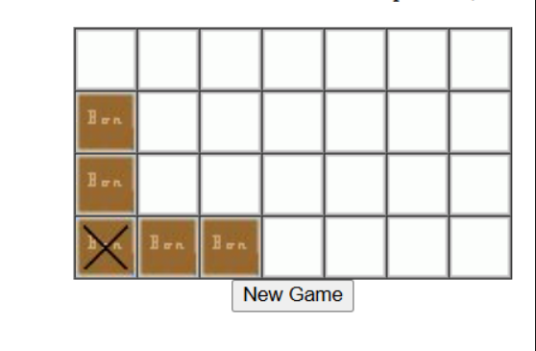

The winning strategy for a player is to get the other player to achieve a square shape. If the arrangement is symmetric (as shown above), the player playing first loses, as the opposing player can easily win by simply copying the moves.

If the bar is n*n, the player playing first can win by eliminating all the n-1*n-1 blocks in the right corner.

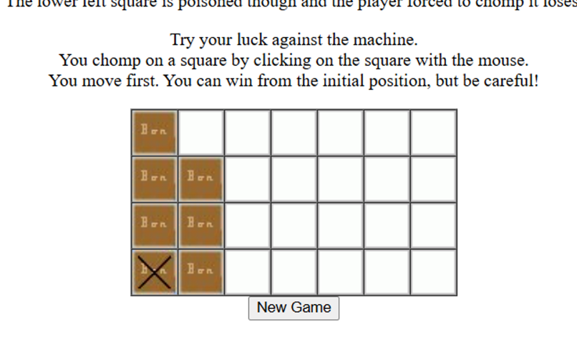

This position was also found to be winning for the player moving second. A system of moves isolates a single square like the image above.

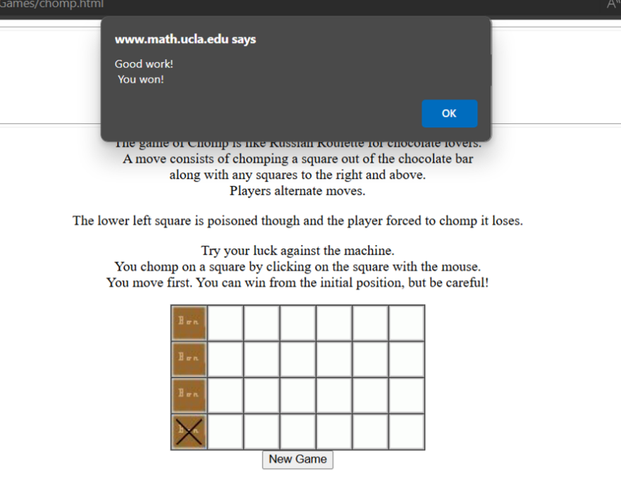

I could win a few games by forcing this strategy but could not recursively apply it as nicely as the computer.

It is expected that there must be a winning sequence, similar to the game of Nim. However, I was only able to discover certain winning positions, which were to be sought after to win the game.